Instructions for data file stripper.

- Make sure you have a single directory with all the files from a particular experiment. For example, on my disk that Mohsen gave me the files are located in D:\data\rawdata\deploy2 (D is a drive letter).
- Make sure all delivered code is in a single directory (the zip file uses “Mohsen” as the dir. That name is arbitrary).
- You must have the DAQ and Signal Processing toolboxes to run this code.
- From the MATLAB prompt, run “interactive_extract_matched_filter_signals”.

The default dialog looks like:

use existing working file list (0=no, 1=yes)? (default 1) 1
use new data file directory (1=yes)? (default 0)0
1 udel lowband
2 udel midband
3 udel highband
enter number of band to get (default 1) 1
1 qCW1
2 qCW2
3 qCW3
4 40msec
5 80msec
6 160msec
7 320msec
enter signal type to get (default 7) 7
1 20030701T123334.daq 2 20030701T130229.daq 3 20030701T133126.daq 4 20030701T140426.daq
5 20030701T143317.daq 6 20030701T150212.daq 7 20030701T163225.daq 8 20030701T170118.daq
9 20030701T173418.daq 10 20030701T180315.daq 11 20030701T183207.daq 12 20030701T190101.daq
13 20030701T193401.daq 14 20030701T200257.daq 15 20030701T200659.daq 16 20030701T203150.daq
17 20030701T203555.daq 18 20030701T210447.daq 19 20030701T210852.daq 20 20030701T213744.daq
21 20030701T220201.daq 22 20030701T223059.daq 23 20030701T230354.daq 24 20030701T230756.daq
25 20030701T233252.daq 26 20030701T233654.daq 27 20030702T000146.daq 28 20030702T000950.daq
29 20030702T003445.daq 30 20030702T005631.daq 31 20030702T015755.daq 32 20030702T025506.daq
33 20030702T035700.daq 34 20030702T040102.daq 35 20030702T045453.daq 36 20030702T050258.daq
37 20030702T053150.daq 38 20030702T053954.daq 39 20030702T055644.daq 40 20030702T060047.daq
41 20030702T065433.daq 42 20030702T073942.daq 43 20030702T085742.daq 44 20030702T093920.daq
45 20030702T095532.daq 46 20030702T103232.daq 47 20030702T105730.daq 48 20030702T115515.daq
49 20030702T115917.daq 50 20030702T120319.daq 51 20030702T123216.daq 52 20030702T125707.daq
53 20030702T135421.daq 54 20030702T145615.daq 55 20030702T152508.daq 56 20030702T155807.daq
57 20030702T160209.daq 58 20030702T162701.daq 59 20030702T163103.daq 60 20030702T165557.daq
61 20030702T172453.daq 62 20030702T175748.daq 63 20030702T182644.daq 64 20030702T195657.daq
65 20030702T202549.daq
enter file number from above list (0 to exit) (default 1)

The responses in red above are the defaults indicated, so you don’t need to enter them. When the time comes to process other signals (e.g., signal type 6, the 160 msec signal), you can type it in to override the default. The files listed above are taken from the working list I generated by searching all files for signals of type 7 (type 7 has the highest signal to noise after processing). Note that they fall 0-10 minutes and 30-40 minutes after the hour for the first part of the experiment. Then, on the afternoon of 7/2 they change to 20-30 minutes and 50-59 minutes after the hour. I think that this is because the source operator reprogrammed his transmission times. No files after 2100 hours on the 2nd were found to contain valid acoustic data.

When you enter a file number, the program uses the specified signal as a matched filter to convolve with the entire data record in the file. The amplitude of the signal is taken and the result low-pass filtered to give a graphic display of the average signal amplitude over the entire signal duration. The resulting graph looks like this:
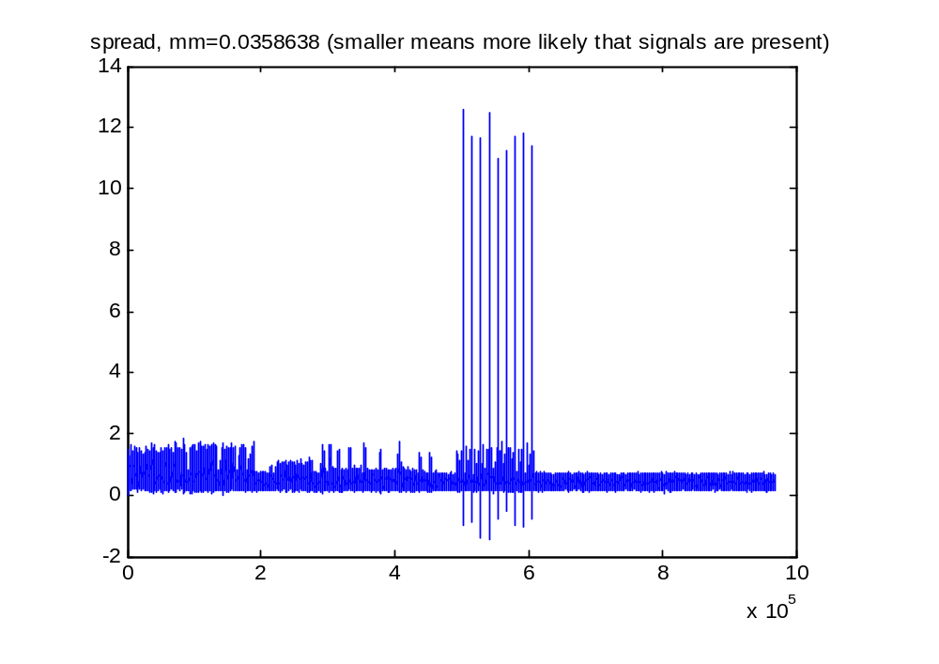

The nine processed signals are clearly visible. You will be asked to click on two points to delineate the region in which to search for peaks:

Click on 2 opposite corners of a box that encloses peaks then hit enter when done.
(to reject, just hit return) then hit return

The points shown above are sample points that serve to isolate the peaks both in time (samples along the x axis) and amplitude (signals above the lower limit are not examined for peaks). The red box above shows the region outlined by the two clicks. You may click more than twice on the plot but only the last two clicks will be used. No indication appears on the graph of where you clicked but the coordinates of the point appear in the edit box to the lower right of the plot. The scroll bars can be used to pan and zoom the region of interest.

After you click, the following messages will appear:

9 peaks found
save data? (default 1) 1
saving data

Data is saved in the subdirectory .\data

The dialog will then repeat the list of files so you can choose another. To quit, type 0 for the file number.

